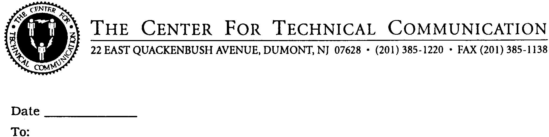

EVALUATION FORM

- Please rate the seminar:
( ) Excellent
( ) Very Good
( ) Good
( ) Fair
( ) Poor

- Please rate the instructors:
( ) Excellent
( ) Very Good
( ) Good
( ) Fair
( ) Poor

- What did you find most useful in the seminar? What did you
like best?

- What could be improved or added to make the program more
useful to you?

NOTE: Your comments may be excerpted in our seminar announcement
mailings.

Name:
Title:
Company:
City:
State:

