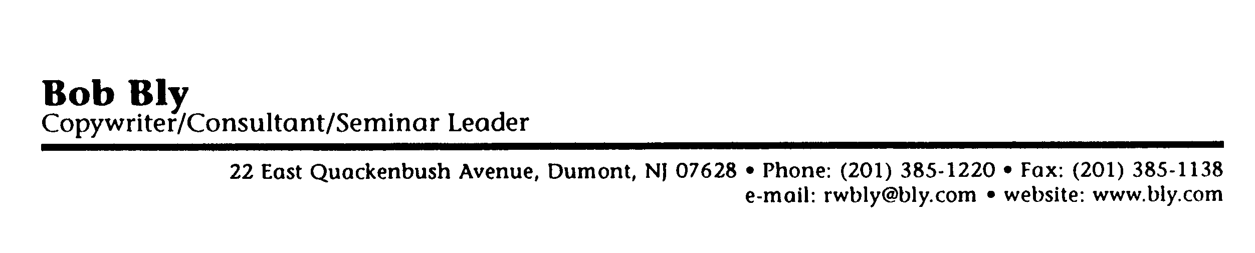

Pre-Program Questionnaire

This questionnaire is designed to help me tailor our seminar to the specific needs, interests, and background of the audience.

Please answer each question as best you can and return this form to our office. Thanks!
- Program you would like us to present for you:
[ ] Effective technical writing
[ ] Effective business writing
[ ] How to write copy that sells
[ ] How to use direct mail to generate more leads and sales
[ ] Selling your services
[ ] Successful selling
[ ] Keeping clients and customers satisfied
[ ] 14 ways to sell any product or service in a recession
[ ] Other:

2. Tell us a little more about the group.
Number of people who will be in the audience:
Average age:
Male/female ratio:
Annual personal income [if relevant]:
Educational level:
Average number of years with company or organization:
Job titles/functions of people in the audience:

3. Which of the following best describes the attitude of the majority of your audience toward our
upcoming training session?
[ ] Very eager and enthusiastic--really looking forward to it
[ ] Somewhat eager and enthusiastic-if perhaps a tad skeptical about our ability to deliver
something they can use
[ ] Neutral-neither enthusiastic nor skeptical-their attitude is "show-me"
[ ] Not terribly interested but not unhappy about going
[ ] Hostile. bored, or both-don't want to go and are being forced to by supervisor or manager
[ ] Smug---think they already "know it all"
[ ] Other:

4. How well educated is the audience in the topic of the seminar?
[ ] They're all experts-the presentation should be advanced and on a high level
[ ] They're fairly knowledgeable but recognize there's always more to learn and room for
improvement
[ ] They have some knowledge of the topic but haven't been exposed to it that much
[ ] They're novices and require a strong education in the fundamentals
[ ] Other:

5. What are the three most pressing challenges or problems faced by the members of your group?

6. Which professional speakers have you previously used to present programs on my topic?

7. Aside from #7 above, what are the three most significant events or trends to have occurred in your
industry, or within your company or group, during the past year or so?

8. What are your specific objectives for our program? (e.g.. what skills do you want your people to gain,
what changes in attitude do you desire, what actions do you want them to take as a result of the training, etc.?)

9. What specific information, strategies, techniques, or topics in particular do you want to make sure I
cover in the program?

10. Are there any issues or topics that you want me to avoid during the program?

11. Have you any other suggestions or advice to help me make this program your best ever?

Instructions:
Please complete this form and mail it back to us at the address below:
Return to:
Bob Bly Seminar Leader/Consultant/Copywriter
22 E. Quackenbush Avenue
Dumont, NJ 07628
phone (201) 385-1220 • fax (201) 385-1138

© Copyright 1992 Bob Bly

