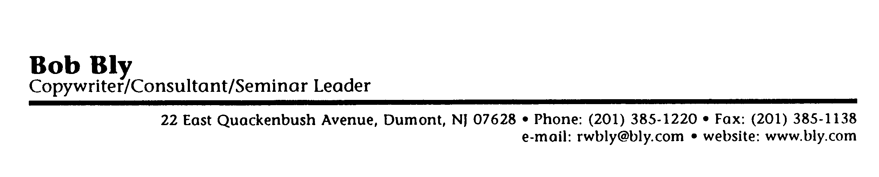

Please Complete and Return This Form

1. Name Title
Company Phone

2. Which of the following best describes the type of writing you do?
business writing technical writing copywriting
other:

3. Which of the following do you write as part of your job?
ads articles brochures catalogs
direct mail letters manuals memos
proposals reports speeches
white papers websites online content
e-mail
others:

4. Please attach one or two short samples of your writing-1 to 2 pages each at most.

5. Which of the following writing problems do you have?
Deadline too tight
Copy is ruined in the approval process
Subject matter too technical for me to understand
Conducting effective interviews
Finding and using suitable graphics to go with my copy
Overuse of technical terms, buzzwords, and jargon
Overuse of cliches
Making spelling mistakes
Proper use of punctuation marks
Using correct grammar
Making complex subject matter clear and understandable
Making dull subject matter interesting to the reader
Expressing numbers and mathematical terms in writing
Overuse of abbreviations
Creating attention-getting headlines and subheads
Writing abstracts of longer pieces
Use of tenses
Keeping ideas in writing parallel
Overuse of antiquated phrases and stuffy language
Paragraphs and sentences too long
Words too big
Being concise and writing to fit the available space
others:

- What questions about writing do you have that you would like us to answer in the seminar for you?

- What do you want to learn in this seminar?

- On a scale of 1 to 10 (10 = superior, 5 = average, 1 = poor), how would you rate your writing skills:

- What would it take to increase your rating of your writing skills to an 8, 9, or 10?

- Any other requests, suggestions, or comments?

Mail to: Bob Bly
CTC
22 E. Quackenbush Ave.
Dumont, NJ 07628
Fax to: (201) 385-1138
Call: (201) 385-1220

© 1993 The Center for Technical Communication

