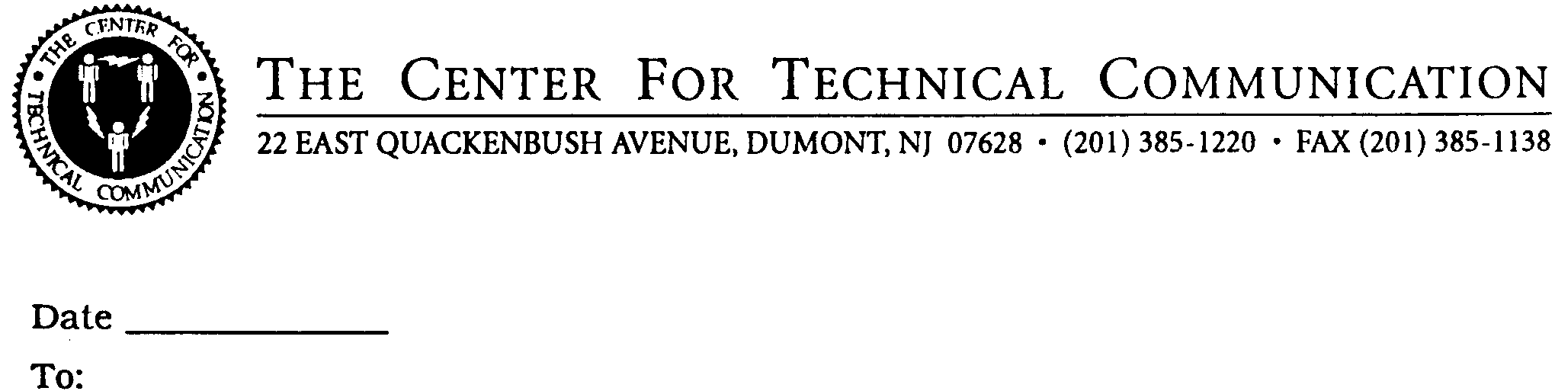

# EVALUATION FORM

1. **Please rate the seminar:**

**( ) Excellent**

**( ) Very Good**

**( ) Good**

**( ) Fair**

**( ) Poor**

1. **Please rate the instructors:**

**( ) Excellent**

**( ) Very Good**

**( ) Good**

**( ) Fair**

**( ) Poor**

1. **What did you find most useful in the seminar? What did you**

**like best?**

1. **What could be improved or added to make the program more**

**useful to you?**

## NOTE: Your comments may be excerpted in our seminar announcement

**mailings.**

**Name:**

**Title:**

**Company:**

**City:**

**State:**