Are Business people Devoid of Emotion When Making Buying Decisions?

By Robert W. Bly

There are two schools of thought concerning marketing to business and technical buyers.
The first school says, “Copy should be as short as possible, direct, and to the point. Bullet lists are better than sentences and paragraphs. Don’t do any selling. Just give business buyers the facts, data, and specifications they need to make an intelligent decision about buying your product. No need to state the benefits. They already know they need the product and why. You just have to convince them that your brand is superior to other products in the category you compete against, and that your product satisfies their application’s requirements.”
Advocates of this “rational” school of B2B marketing believe that business prospects, at work, are largely rational beings that make logical decisions based on facts. They strive to keep written communications as short as possible, in the belief that all businesspeople are extremely busy with no time to read.
“Business-to-business copy should be completely fact-based,” says LT, a veteran B2B marketer. “And the less there is to read in your copy, the greater your response rates will be. Long copy in B2B gets tossed in the trash.” LT also advises that copy written for B2B audiences should sound professional rather than conversational. “These are educated people,” he says, “and you must talk to them on their own level, which is high.”
The other school of B2B marketing is the “emotional” school. Their philosophy was articulated to me by HF, who owned a successful industrial ad agency in the 1980s. HF said: “The business prospect doesn’t stop being a person when he sets foot in the office. He is a human being first, and an executive or engineer second. Therefore, the same psychological factors motivate him as a human being whether he is at work or at home.”
The emotional school of B2B marketing uses copy and design that reads and looks more like consumer advertising than technical writing. The copy style is personal and conversational, tapping into the prospect’s needs, concerns, fears, and desires.
“Because business customers are persons, communications to them should try to connect on a personal level,” says B2B copywriter Ken Norkin. “That means starting out by conveying an understanding of the customer’s situation and in particular the problem that your product is going to solve. You not only need to present the data but tell your readers what it means to them.”
Now, most marketers divide the marketing world into two segments: business-to-business marketing and business-to-consumer marketing. The “rational” school of B2B marketing says business and consumer not at all the same. The “emotional” school says that B2B and B2C marketing are more alike than they are different.
But I actually think there is a third segment, real but rarely recognized: hybrid marketing (see Fig. 1). Hybrid markets are those that exhibit characteristics of both business prospects and consumers. Hybrid prospects are consumers who exhibit many of the behaviors shared by business prospects or vice versa.
An example of a classic hybrid market is SOHOs – small business/home business. These are for the most part self-employed people working at home or a small rented office. Typically they work along. Some have a small staff.
Technically, since they are business owners, selling to SOHOs is B2B marketing. But SOHOs often behave more like individual consumers than corporate executives, engineers, or IT professionals.
For a corporate middle manager, the purchase of an expensive color digital printer may indeed be a largely dispassionate decision: one of my tasks she must content with that week.
The SOHO is more likely to agonize over this purchase decision. The expense of the equipment is much more of an emotional issue, since it is coming out of the SOHO’s pocket: he may have to decide between buying the printer vs. sending his kid to camp that summer. In addition, the SOHO may cultivate a personal excitement from this purchase (having coveted but never owning office equipment this high-tech or costly before) that the corporate employee does not feel.
Farmers are another hybrid market. The family farm is their legacy and livelihood, and there are few issues more emotionally charged than keeping it as a growing concern and passing it on to the children. Yet, a farm is a business, and therefore farmers are, strictly speaking, a B2B and not a consumer market.
I am unaware of any authoritative study on whether business-to-business marketing (and marketing to hybrid markets that exhibit some B2B characteristics) works better when it is reduces to the bare essential facts or written on a personal and emotional level. So I can only relate what I have found during my three decades as a B2B copywriter. And based on that long experience, here is what I believe works in B2B copy as a rule:
>> Business-to-business prospects are far less dispassionate about their jobs and industries than is often imagined. For example, I attended a technical seminar years ago where two telecommunications managers both turned red in the face and nearly came to blows in a heated argument about whether TDMA or CDMA was the better platform for wireless communications.
>> The business prospects buys not only for his company but for his own personal benefit, and the two are sometimes at odds. Often a prospect will specify a product that may not be the optimum solution for his company’s problem if he believes it will personally make his life easier or his employment more secure. This is why for years the maximum in IT was no IT manager ever got fired for buying an IBM product that didn’t work. Even if another brand had superior features or better price/performance, IBM was the safer choice for IT buyers who answered to senior management.
>> While B2B prospects can be engaged and sold emotionally, once that engagement takes place, B2B prospects require much more rational evidence to support their buying decisions than consumers.
So the answer to our question “Are B2B prospects devoid of emotion?” is decidedly “no.” On the contrary, and despite what they themselves may say, much of B2B buying is motivated by emotional reasons rather than logical facts.
However, the emotion in B2B marketing typically comes in the front-end of the sale, which involves attention-getting and engagement. This is the place in the B2B sales cycle where emotion-driven consumer advertising techniques maximize marketing effectiveness. An example is the current TV campaign for Macintosh vs. Microsoft, where Apple computers are positioned as cooler, friendlier, and problem-free.
Once emotion hooks the B2B prospect, and he begins a serious evaluation of your product, logic and intellect take over. He gradually shifts from an emotional buyer (though residue of his emotional reaction to your marketing stays with him throughout the sales cycle) and increasingly toward a rational mode of decision-making.
At this stage, the prospect is performing due diligence. He has to make sure the product can perform the functions required, fits the application’s requirements, is compatible with his current infrastructure, has the proper specifications, and can handle the buyer’s application. Here is where traditional informational, fact-based, content-rich B2B marketing – data sheets, brochures, white papers, podcasts, and webinars – are most useful to buyers, because they contain answers to the buyer’s due-diligence research questions.
Fig. 1. The 3 markets: B2B, B2C, hybrid.
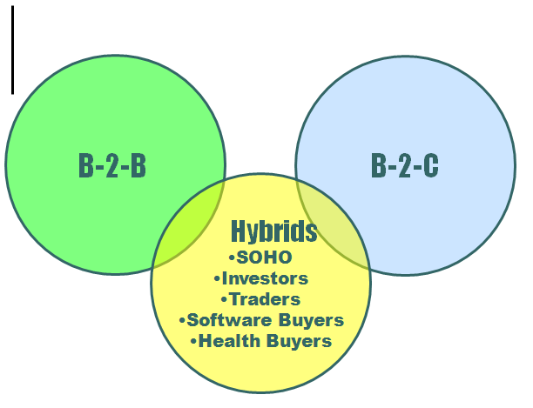

About the author:
Bob Bly is a freelance copywriter and the author of more than 70 books including The White Paper Marketing Handbook (Racom). You can find him on the Web at www.bly.com, e-mail him at rwbly@bly.com, or phone 201-385-1220.
###

